2022 Juried Dream Art Exhibition Entry Form
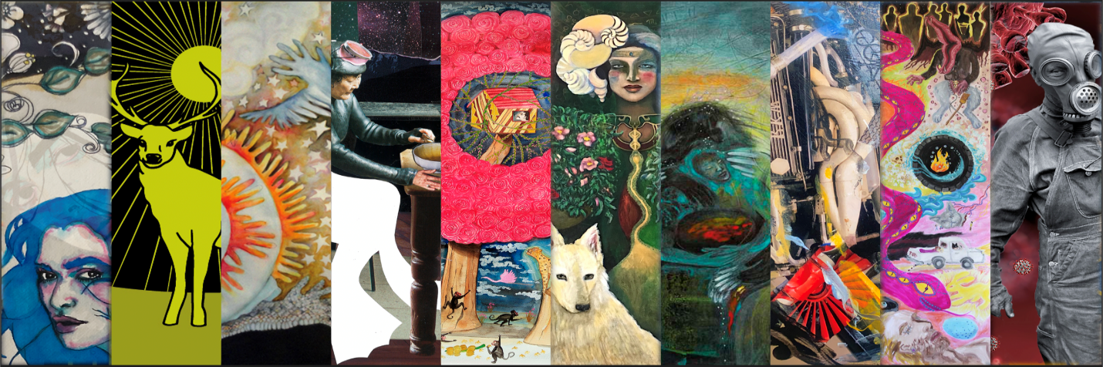
The deadline for entries is midnight,
Tuesday, March 31, 2022, GMT
Please enter your Email Address here and you will receive an email confirming receipt of your submission. *
Please re-enter your Email Address. *

General Information
First Name and/or initials *
Last Name *
Street Address or PO Box *
City *
State/Province/Region (where applicable)
Zip/Postal Code *
Country *
Primary phone number *
Secondary phone number

Are you a current IASD member? *
Yes
No
You may enter up to FIVE (5) art pieces. Total number you are submitting: *

Please tell us how you learned about this art exhibition. *
IASD website
Facebook
Instagram
Email
Heard about it from a friend/colleague
Other (please specify)
Do you give IASD permission to exhibit images of your work online, with full credit to the artist, as part of the Dream Art gallery on the IASD web site? *
Yes
No
Do you give IASD permission to reproduce one or more of your images, with full credit to the artist, in DreamTime, the members-only publication of IASD? *
Yes
No
I confirm that a high resolution (300dpi) version of each submitted image is available should IASD require it for print in any IASD publication. *
Yes
No
Do you want your work to be considered for Dream Art Awards? *
Yes
No
Sale of your art. If you wish to have your work available for purchase by attendees, you may indicate your suggested purchase price in the space provided with each work.
If anyone wishes to purchase a work, it is our policy that they negotiate directly with the artist, so we will include your email address with the item so that the buyer can connect directly with you.
We do ask (and expect) artists to make a donation to IASD, normally 20% of the sales price. This is some compensation for having made the work available for purchase through our exhibit. You may make your donation through http://www.asdreams.org/. Go to ¨About IASD¨ and then the ¨Make a Donation¨ link. Or you may simply send a check to the IASD Central Office at IASD PO Box 206 Novato, CA 94948.
Biographical Sketch *
Artist Statement - Please explain how your work is dream-related. An entrant can create a piece inspired by someone else’s dream. If the art was not inspired directly from a dream of the artist or other person that occurred during sleep, include documentation to show how the art is directly related to such dreams. *
Special requests or comments. For VIDEO entry, please provide the link to where the entire video can be viewed by the judges and attendees (i.e., YouTube).

Images
Reminder: Image requirements:
- Files should be in JPEG format only.
- Images should display in the proper orientation, with resolution set at 72 dpi and sized to open no larger than 8” x 10”.
- The maximum total file size is 1 Megabyte per image.
- Artists are requested to compress individual JPEG files to a maximum per images sized at 576 px by 720 px at 72 dpi (or 720px by 576px).
- Image file names should include the artist's name and an image number (e.g. "Smith1," Smith1detail”, "Smith2," etc.").

NOTE: If you are submitting a Video for consideration, please load it on a format such as YouTube and provide the link in the Special Requests or Comments section above. Also, please upload an image or images from the video in the upload block(s).
Image #1 - Title *
Image #1 - Image size (height x width in inches) *
Image #1 - Medium/media
(indicate all materials used in the work; examples: acrylic paint, wood, metal, feathers, canvas) *
Image #1 - Price in US dollars or NFS (not for sale). See note above regarding IASD´s policy on sale of art. *
Image #1 - Dream Text
Please explain in 100 words or less how your work is dream-related. Note that this text will be posted with your art piece at the exhibit.
An entrant can create a piece inspired by someone else’s dream. Please provide the text of the dream or the significant part of the dream that inspired the work. If the art was not inspired directly from a dream of the artist or other person that occurred during sleep, include documentation to show how the art is directly related to such dreams. *
0/100 words
Image #1 - Upload properly formatted jpg digital image file. See reminder above for format instructions.
To ATTACH and UPLOAD the image,
1. click BROWSE to find the file, then after the file name appears in the browse window,
2. click UPLOAD to attach it. *

Image #2 - Title
Image #2 - Image size (height x width in inches)
Image #2 - Medium/media
(indicate all materials used in the work; examples: acrylic paint, wood, metal, feathers, canvas)
Image #2 - Price in US dollars or NFS (not for sale). See note above regarding IASD´s policy on sale of art.
Image #2 - Dream Text
Please explain in 100 words or less how your work is dream-related. Note that this text will be posted with your art piece at the exhibit.
An entrant can create a piece inspired by someone else’s dream. Please provide the text of the dream or the significant part of the dream that inspired the work. If the art was not inspired directly from a dream of the artist or other person that occurred during sleep, include documentation to show how the art is directly related to such dreams.
0/100 words
Image #2 - Upload properly formatted jpg digital image file. See reminder above for format instructions.
To ATTACH and UPLOAD the image,
1. click BROWSE to find the file, then after the file name appears in the browse window,
2. click UPLOAD to attach it.

Image #3 - Title
Image #3 - Image size (height x width in inches)
Image #3 - Medium/media
(indicate all materials used in the work; examples: acrylic paint, wood, metal, feathers, canvas)
Image #3 - Price in US dollars or NFS (not for sale). See note above regarding IASD´s policy on sale of art.
Image #3 - Dream Text
Please explain in 100 words or less how your work is dream-related. Note that this text will be posted with your art piece at the exhibit.
An entrant can create a piece inspired by someone else’s dream. Please provide the text of the dream or the significant part of the dream that inspired the work. If the art was not inspired directly from a dream of the artist or other person that occurred during sleep, include documentation to show how the art is directly related to such dreams.
0/100 words
Image #3 - Upload properly formatted jpg digital image file. See reminder above for format instructions.
To ATTACH and UPLOAD the image,
1. click BROWSE to find the file, then after the file name appears in the browse window,
2. click UPLOAD to attach it.

Image #4 - Title
Image #4 - Image size (height x width in inches)
Image #4 - Medium/media
(indicate all materials used in the work; examples: acrylic paint, wood, metal, feathers, canvas)
Image #4 - Price in US dollars or NFS (not for sale). See note above regarding IASD´s policy on sale of art.
Image #4 - Dream Text
Please explain in 100 words or less how your work is dream-related. Note that this text will be posted with your art piece at the exhibit.
An entrant can create a piece inspired by someone else’s dream. Please provide the text of the dream or the significant part of the dream that inspired the work. If the art was not inspired directly from a dream of the artist or other person that occurred during sleep, include documentation to show how the art is directly related to such dreams.
0/100 words
Image #4 - Upload properly formatted jpg digital image file. See reminder above for format instructions.
To ATTACH and UPLOAD the image,
1. click BROWSE to find the file, then after the file name appears in the browse window,
2. click UPLOAD to attach it.

Image #5 - Title
Image #5 - Image size (height x width in inches)
Image #5 - Medium/media
(indicate all materials used in the work; examples: acrylic paint, wood, metal, feathers, canvas)
Image #5 - Price in US dollars or NFS (not for sale). See note above regarding IASD´s policy on sale of art.
Image #5 - Dream Text
Please explain in 100 words or less how your work is dream-related. Note that this text will be posted with your art piece at the exhibit.
An entrant can create a piece inspired by someone else’s dream. Please provide the text of the dream or the significant part of the dream that inspired the work. If the art was not inspired directly from a dream of the artist or other person that occurred during sleep, include documentation to show how the art is directly related to such dreams.
0/100 words
Image #5 - Upload properly formatted jpg digital image file. See reminder above for format instructions.
To ATTACH and UPLOAD the image,
1. click BROWSE to find the file, then after the file name appears in the browse window,
2. click UPLOAD to attach it.

Detail Images
You may submit one or two images that provide greater detail for one or two of your entries. Please identify the specific image number and title of each image.
Identifying information for first Detail Image. Please include title and image number.
First Detail Image - Upload properly formatted jpg digital image file. See reminder above for format instructions.
To ATTACH and UPLOAD the image,
1. click BROWSE to find the file, then after the file name appears in the browse window,
2. click UPLOAD to attach it.

Identifying information for second Detail Image. Please include title and image number.
Second Detail Image - Upload properly formatted jpg digital image file. See reminder above for format instructions.
To ATTACH and UPLOAD the image,
1. click BROWSE to find the file, then after the file name appears in the browse window,
2. click UPLOAD to attach it.

Submission
By pressing the SUBMIT button below, you acknowledge your understanding that submission of works to this exhibition shall constitute an agreement by you to all conditions set forth in the Prospectus, including the following:
- All art accepted for the show must be hand-delivered to the Loews Ventana Canyon Resort. The Resort is not able to accept shipments.
- IASD or the Resort will not be responsible for any loss or damage to the work during installation or during the exhibitions. INSURANCE IS YOUR RESPONSIBILITY.
- To have your work considered by the jury, you are required to pay a NON-REFUNDABLE submission fee of $40 (per artist), which is waived for artists who have registered for the conference. You will be provided with a link to the payment site in the email you receive acknowledging receipt of your submission.
This is all of the information you require to submit an Art Entry Form. On the actual entry form you will see a Submit button at this point. Once you have verified that all of your information is correct, you may press the Submit button to send your proposal to the Conference Visual Art Committee.
Return to the Call for Art Entries page (https://iasdconferences.org/2022/call-for-artwork-prospectus/) and insert this information into the Online Entry Form.

