Guidelines for On-Site Presenters
Thank you for participating in the IASD 39th Annual International Conference at the Loews Ventana Resort in Tucson, Arizona. With the conference about a month away, we wanted to orient all presenters regarding what to expect and how to properly prepare for your presentation. Please read carefully to ensure that your presentation goes as planned. The program listing, abstracts, biographies and schedule are online at https://iasdconferences.org/2022/ so make a final check to note the day and time of your presentation(s) as well as other information about the conference, lodging and meals.

Questions?

Questions regarding the program should go to program@asdreams.org, and will be distributed to our Program co-Chairs Bob Hoss and Katherine Bell and Registration/Office Manager Alina Mansfield.

Audio-Visual and Room Setup
Room Set-up:
In terms of set-up, we have tried and pretty well succeeded in meeting your requests; however, since almost every room is used by others during the conference, the chairs may not be exactly in the configuration you requested (some workshops and Morning Dream Groups). We have tried to place these in rooms that can accommodate your set-up if you move the chairs a bit – but please when you are done move them back (you can also ask the Room Monitor to help). DO NOT under any circumstances move the AV, which is usually stationed on the podium, or the wires taped down to the audio and projection systems. This will make it very difficult for the next presenter and will often leave the AV in non-working order. If you have to plug in your own laptop, ask the AV Volunteer to assist and make sure you only unplug the cable you need (HDMI usually), and plug everything back when you are finished.

The session spaces used for lectures, symposia, panels, and a few workshops requesting AV are equipped with just you requested, but often more the set-up was based on all users of the room - such as a digital projector, a laptop, plus a lavalier microphone for the speaker and a floor microphone for audience questions. Panels have an additional table microphone.

In a few Art Workshops we were unable to provide enough chairs as requested around the table setting (a 36 chair U-Table setup), so your Schedule at a Glance now shows a number on which may differ from the maximum you requested. Specialty items such as art supplies and pillows/yoga mats must be provided by the presenter. If you have a question about some non-standard piece, best ask ( program@asdreams.org )or prepare to find it locally when you arrive.

Audio/Video:
All that you listed in your presentation proposal should be in the room for you, plus a bit more. There may be a couple of sessions for which we are not able to provide AV (such as a projector in the Foyer, for example) and for the smaller workshops microphones/sound is not available in those smaller rooms.

If You Want Your Presentation to Work Smoothly, Read This!

• Bring Your Presentation on a Thumb Drive: You must bring your PowerPoint or video/audio presentation on a USB flash drive (thumb drive) since the hotel laptops have NO CD drives (with 1 exceptioin). When you store your presentation check that the file is actually transferred to the thumb drive (including any imbedded audio/video clips) and test it on a Windows 10 PC before leaving home. Make sure the format of video and audio is common MP3 or 4 and can be easily played on the Windows Media Player.

• Bringing your Laptop only as Backup: Please plan to use the in-house laptop. Don plan on using your own laptop unless absolutely necessary. Connecting and setup/troubleshooting of your laptop on top of the one already on the podium may result in time delays which would impact your presentation time. If you need to use yours, and if it is a MAC or even the latest PC Laptop requiring special adapters, make absolutely sure you bring all connector adapters and cords (HDMI or VGA connector adaptor; audio adapters, power plug/charger). We will likely NOT have them.

• Compatibility: your presentation needs to be Windows compatible to work on the hotel laptops. The operating system will be Windows 10 with Office 10 or 360 for PowerPoint. If you created it on a Mac, we cannot always guarantee compatibility so it is best to test it out on a Windows 10 PC before you leave home if you can. Also plan to go to the AV checkout session in Salons B&C on Sunday afternoon from 1 to 5 PM Pacific time. Too often presentations that worked just fine on a unique program of software version or operating system on your home computer may not work here and there will likely be no remedy.

• Video/Misic or Film? For those who indicated that they may play a video we tried to assign them to the only room (Salon J) that has a CD/DVD drive in the laptop plus we may have a standalone DVD player in Salon F for the one session there – BUT – do not rely on them working properly or without a lot of fiddling – put your videos on a thumb drive as well. If you only feel comfortable with your own laptop make sure it has an HDMI port for video connection to the projector and a standard audio port for audio or music (headphone jack) – and check with the AV support early/day before on connect ability – or bring your adapter cords. Windows Media Player should play the following formats: m4v .mp4 .mov plus a few more (try your video at home on a Windows 10 device beforehand).

• Wi-Fi Connection: There are wireless 5+ Mb/s Wi-Fi internet connections in the rooms where we are recording (mainly invited presenters, symposia and panels), but the quality can always be an unknown with shared wireless systems. It is best to present from your PC, and NOT from the “cloud” but if you wish to take that chance, you’d better bring a backup copy that you can present directly from the PC.

- If you must use your own Laptop learn/set the projection commands BEFORE you arrive. Practice using the laptop’s external display commands and pre-set them before you arrive (often unless set correctly, what you see on your laptop screen is not what is being displayed). Don’t assume that your AV Volunteer will know; there are just too many laptop brands and versions, so learn how to operate YOURS and test that screen/projector command before you come. Test in in Sundays AV checkout session at 1 to 5 PM in Salon B&C.

- Practice your presentation on Zoom if you are in a Recorded Session. If your presentation is one that is listed as recorded (“Record” highlighted on the schedule) then you will be presenting using the Zoom application and the “Share Screen” function. If that presentation has embedded video or sound you will also need to remember to click ”share sound” in the zoom share screen pop-up box where the icon of you presentation top page image is displayed. A detailed Guide to Zoom is included below. Please practice screen sharing your presentation on Zoom at home – you can do it without going online even if you have the free Zoom launcher application on your computer.

When You Arrive

- Presenter AV Checkout: It is best to check your presentation beforehand on the equipment to be provided. AV checkout can be done in the ballroom sections Salons B&C on Sunday afternoon from 1 to 5 PM. There will be techs there to assist.

- Onsite Contacts: some of the contacts you may need at first are listed below. A full list can be found at the registration/information desk. Please don’t distribute, since these are their personal cell phone numbers just for conference use

Conference Management Team (Onsite Support)
- IASD Conference Manager & Program Co-Chair: Bob Hoss 1-602-722-9000
- Program Co-Chair: Katherine Bell 1-831-234-1412
- Office and Registration Manager: Alina Mansfield 1-510-684-2056
- Onsite Registration Co-Chair: Bob Krumhansl 1-410-961-6512
- Room Monitor Manager: Geoff Nelson 1-562-201-6521
- AV Volunteer Manager: Jeff Armano 1-978-944-1576
- Recording Manager: Scott Sparrow 1-956-367-2337
- CE Manager: Remy Mallett 1-314-983-8671
- On site Research Track Chair: Remy Mallett 1-314-983-8671
- Bookstore: Breakpoint Books - Dave Hemsath 1-216-496-3482
- Crisis Intervention (Emotional)
- Alan Siegel - 1-510 734-7929
- Gregory Scott Sparrow - 1-956-367-2337
- Kim Mascaro (Ethics Co-Chair, Emotional Crisis support) 1-510-277-5595
Medical or physical emergency: should be reported to the Hotel reception desk; you can call from a house phone and please dial ‘0’; or, if immediate, you can also call 911 for medical emergencies

Presentation Protocol for Your Session

- Pre-load your Presentation. Find the room that you will be later presenting in, and the day before or during a meal break pre-load your presentation onto that laptop and leave the icon on the screen with a name you will recognize. We will have asked that the hotel AV keep laptops in the same rooms each day, so you could do it the day before – but just in case make sure it is still there on the day of your presentation.

- Arrive 15 Minutes before your session. If you are a single presenter or the session chair, locate and introduce yourself to your Room monitor and AV Volunteer. If you are a presenter in a symposium or panel, introduce yourself to the chair (notated in the Schedule)

• Immediately load your presentation if you have not done so already. If there are multiple presenters, just load your file onto the screen (plug in thumb drive and drag and drop from the pop-up menu, leave it on the screen with a file name you recognize) then let the next presenter load theirs. The AV Volunteer will help you load it if needed, and when ready can help with your microphone and projecting your presentation as well as adjusting volumes and dimming lights.

• The Room Monitor will ask you or the session Chair to let them make an announcement at the start of the session (regarding CE participation, recording, timing, using the Floor Mic for questions from the floor, and general help). They are there to help time your presentation and to provide timing cues so you end on time (see below).

• Introduction: If you are the sole presenter, start your session with a welcome introducing your talk title and name. If you are the chair introduce the sessioin title or topic, and each presenter’s name in the order they are to present. In either case, before presentations begin announce the Room Monitor, who will give a short 1 minute announcement.

• Timing / Start and End On Time: ask your Room Monitor to time each presentation so that each presenter and the whole session ends on time - and gives each presenter the time needed for Q&A. The room monitor will time and prompt each presenter by holding up signs marked 5 minutes, 2 minutes and 0 END. If you want a 5 or 10 min Q&A session ask them to give you another 0 minute cue when the session is to end. There is no extra time to let your talk or session run over time, particularly if you are in a session with others who have to meet their timing limits or if the session only has a 15-minute interval between it and the next. It is unprofessional, and unfair to those who follow, for you to run late, so don’t be surprised or upset that they are entering the room and interrupting your conclusion – it is their right and they are given the same instruction as you to do so. If attendees want to ask you questions after time, then bring them into the hall with you to do so. Standard timings are: Workshops - 60, 90 and 120 minutes (with no Q&A); Invited or special event presentations - 1 hour consisting of 45 to 50 minutes plus Q&A; Talks in a symposium – 30 minutes consisting of 20 minute talk times plus 10 minute Q&A; Panels – 10 to 15 minute talks with 20 to 30 minutes when presenters sit as a panel for Q&A. Any changes to this must be communicated to the Room Monitor at the onset of the session.

- Recordings: Workshops and artistic sessions are not recorded, but if yours is a lecture-based session it likely will be (see the Record notations on the schedule). The laptop will be on the podium, and we will be recording using the Zoom application, and you will also be wearing a lavalier microphone, but you will need to stay in view of the camera (relatively centered on screen). The AV Volunteer can help you navigate Zoom if it’s unfamiliar. You will use the “Share Screen” function and remember to click the “share sound” if your presentation has embedded video or sound. When you get ready, you will need to click the record button (or the AV Volunteer may do it or Room Monitor will remind you), and at the end of Q&A click pause – or if you are the last or only presenter click END and END for ALL Before you begin the session, and when ready for Q&A, the Room monitor will ask people to line up at the Floor mic for questions. A detailed Guide to Zoom is included below. Please practice screen sharing your presentation on Zoom at home – you can do it without going online even if you have the free Zoom launcher application on your computer. We also recommend that when you practice you record it as a backup (in the cloud or on your PC in dropbox) to include in our recording package in case there is a problem on site.
Ethics Guidelines

- IASD Ethics Policy: If you had not done so, please read the IASD dream work ethical statement which you agreed to when you submitted your proposal: https://www.asdreams. org/ethics-and-confidentiality/ . The IASD ethical statement emphasizes non-intrusiveness and respect for the dreamer as final authority on what the dream means to them and requires that the presenter not make unrealistic claims.
- Presentation Ethics:
Attendees to IASD conference sessions do so with the expectation of learning something new from an introduction to new information or approaches – they do not expect a sales pitch on a product, book or service and are often quite offended when that occurs. Overt self-promotion and direct solicitation, such as openly advertising and selling books or services during the presentation is considered unprofessional and unethical and is not permitted during a session. You may reference and discuss your work and where further information can be found in a professional manner, however, if it acts as source material in support of your presentation. The IASD conference provides an Attendee Information Table where you may display information on your events, products or services. The sale of all books and certain products must be done through the conference bookstore.
- Book/Product Sales: In no case shall books and products be sold within a conference session – they shall be sold only through the conference bookstore. If your books were not already requested in your submission, go to the bookstore when you arrive and delivery your books and sign the agreement if you have not done so beforehand.
- Copyright Guidelines to be aware of If your IASD conference presentation is going to be recorded and shared by IASD, you will need written permission from the copyright holder for any copyrighted material (images, music, video, extensively quoted text) used in your conference presentation. If you are unable to clear rights for an image, text, video, or music that you would like to use, you may want to create a second version of your presentation recording for IASD that does not include the copyrighted material. For instance, you could make the recording audio-only, or edit out the images. (You will still need to properly credit the works during your live presentation). Or you can ask that your session not be recorded.

Disability Guidelines for Presenters

These guidelines are intended to aid those with disabilities and are good practice for any audience.
• Reserved Seating: IASD has reserved a few seats in the front row for those individuals who have partial sight or hearing needs. The Room Monitor will assist with this.
• Narrate Your Visual Aids: Describing the information that is being presented on the overhead projector or screen. When you refer to a graphic or slide, please use a pointer or indicate direction (example: “...the red box on the left”).
• Power Point: It is recommended that you include only the key points of the presentation on slides, in large (minimum 28 point) print. Limit the number of slides so there is time to read them. If a picture or chart it is always good to include some of the text that you will use to describe it. Avoid copying much of the text of your presentation on your slides!
• White Board and Flip Charts: If you write on a white board or Flip Chart, write large, and say what you are writing and do not turn away to write while speaking.
Guidelines for using Zoom in Recorded Sessions
Many of you are familiar with presenting over Zoom, but it might still be a good refresher to review this section. If you are not familiar with Zoom, please read it carefully and practice it at home even on a free downloaded Zoom launcher application. An AV Support Volunteer will be available to help you with this if needed but it is good to understand it yourself to avoid delays in presenting.

Step (1) Pre-Load the File
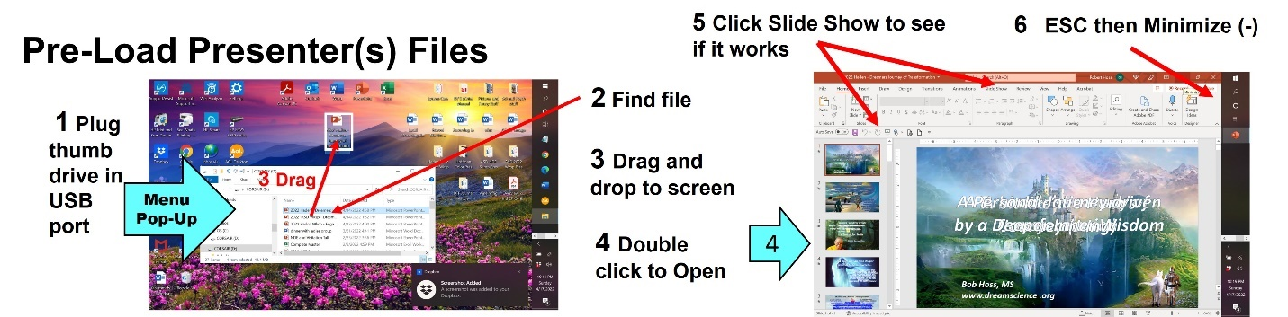

Steps (2 ) – (4) Sequence for Zoom Pres. Launching and Recording

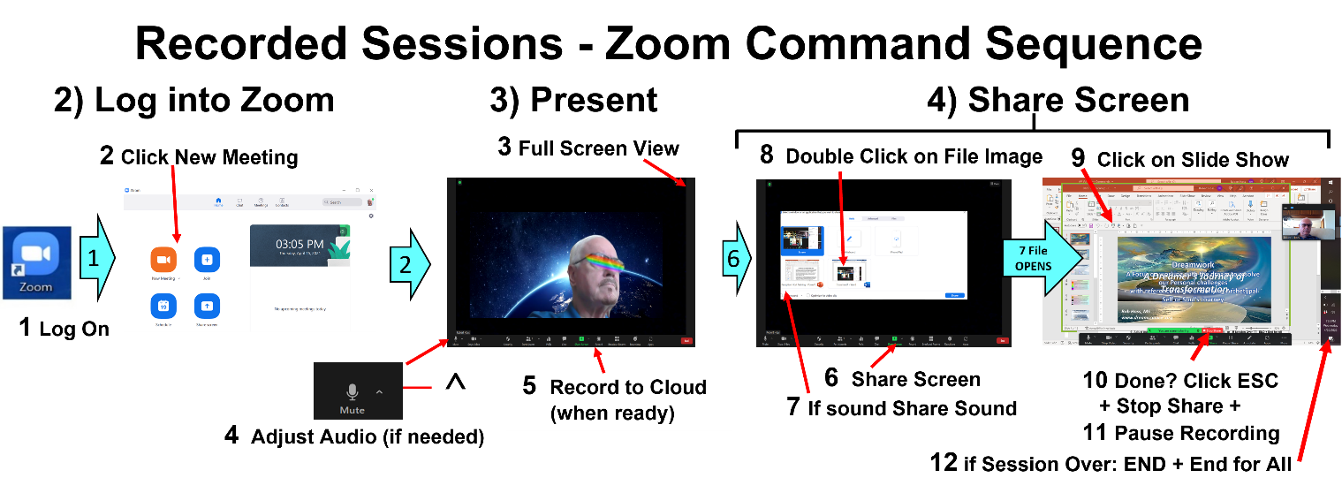
The diagram should be self-explanatory, but the following explains each step if needed:

(1) Pre-Load Files: plug thumb drive in > file listing should pop up > locate your file > drag and drop it on the screen as a file icon. Test it by double clicking > click slide show to test then ESC to get out of slide show > then don’t close it but minimize it (---) so it comes up in Zoom in the pop-up screen that shows active files.

(2) Launch Zoom: at the beginning of the session after files are loaded
- Click on the Zoom icon; the navigation home screen should pop up;
- Click New Meeting, which brings the Zoom video screen up;
- Select Full Screen view in the view icon upper right corner (if you need the computer file navigation menu at any time, just click Esc)
- Adjust Audio (if necessary): click on the up arrow to the right of the MUTE icon (lower left corner of screen); Then click on “Audio Settings;” if necessary, adjust mic and speaker volume using the blue sliders (usually best to place mic on max; speaker only used for the Hybrid session).

(3) Present:
5a When ready to present, click the Zoom RECORD icon (menu on bottom of Zoom screen);
5b Select Record to Cloud [NOTE: if we later find we do not have adequate Wifi quality we may ask you to click Record on the room computer]
5c Try to keep your face centered or present on the screen
5d If you are going to screen share a visual or PP, follow step (4) below.
5e If you are NOT doing a PowerPoint or visual aid, when they finish their talk and Q&A then click the PAUSE RECORDING

(4) Share Screen: if you are sharing a PowerPoint or other Visual Aid, after the introduction:
6. Click Share Screen (green box) once the presenter has finished their introduction.
7. If the Visual Aid has sound , check the Share Sound box (lower left corner of pop-up screen)
8. Find File: The first page image of the file should be lined up along the bottom of the zoom pop-up screen. Locate your file and double click on it. – it will fill the screen and Zoom will automatically go into Share Screen mode, with your face in a small thumbnail off to one side (that can be moved aside by moving the cursor over it while holding the left mouse key down)
9. Slide Show: If a PowerPoint “show it” by clicking on the “Slide Show” icon as normally done when showing a Power Point;
10. Stop Share: it is best first to close the presentation by clicking ESC, then X (Zoom will automatically stop share) – or – ESC then Stop Share button.

(5) Pause/Stop Recording (steps 11 through 12):
a. Symposium: if there is another presenter after you click “Pause Recording” on the black Zoom menu bar. The AV Volunteer may step in to do this.
b. Panel: presenters generally speak in rapid procession and then sit as a panel – the recording will be kept ON until all have presented then the Chair can either leave it recording or hit Pause Recording while moving the laptop camera to capture all seated as a panel.
c) End of Session? if you are the last or only presenter in the session then at the end of your talk 11. click Stop Recording then 12. End then End Meeting for All. Note: if you forgot to stop the recording it will automatically stop and store when you End Meeting for All.

