2023 Juried Dream Art Exhibition Entry Form
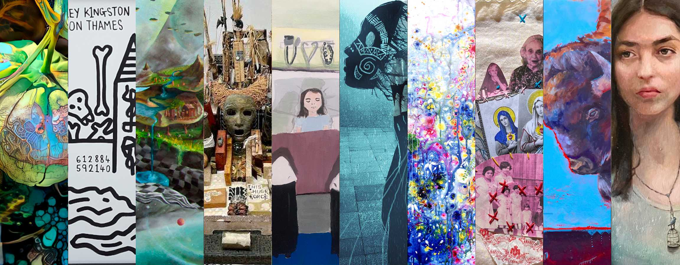
The deadline for entries is 11:59 pm GMT,
Wednesday, March 15, 2023
This is a sample only, to show you what is on the actual art submission form. No buttons included in this sample form actually work. You can enter information into the fields as you draft your replies, but that information will not be transmitted and will not submit your work to IASD.
Remember that art is eligible only if based on dreams that occur during sleep (including lucid dreaming) or shamanic practice. If you have questions about whether your art qualifies, please send them to vac@asdreams.org.
Enter your Email Address. *
Re-enter your Email Address. *
You will receive an email confirming receipt of your submission.

General Information
First Name and/or initials *
Last Name *
Street Address or PO Box *
City *
State/Province/Region (where applicable)
Zip/Postal Code *
Country *
Primary phone number *
Secondary phone number

Are you a current IASD member? *
Yes
No
You may enter up to FIVE (5) art pieces. Total number you are submitting: *

How did you learn about this art exhibition? Check all the categories that apply, and, if possible, name the specific sources in the Other(s) field). *
IASD website
IASD Facebook page
IASD monthly Dream News
IASD DreamTime magazine
Email from IASD Arts Committee
Email/other from IASD regional rep
IASD member told me
Social media - other Facebook page
Social media - Instagram
Social media - Twitter
Social media - other
Call for artwork listings
Organization or school website, email, or newsletter
Independent blog or podcast
Media story/events - newspaper (including online)
Media story/events - magazine (including online)
Media story/event - radio
Media story/event - TV
Heard about it from a friend/colleague
Other(s); also, please identify the checked items by name, if possible.

I give IASD permission to exhibit images of my work online, with accompanying dream text and full credit to me as the artist, as part of the Dream Art gallery on the IASD web site. (NOTE: The online gallery is a permanent part of the IASD website.) *
Yes

I give IASD permission to reproduce one or more of my images, with accompanying dream text and full credit to me as the artist, in DreamTime, the members-only publication of IASD. *
Yes

Do you give IASD permission to reproduce one or more of your images, with accompanying dream text and full credit to you, in other IASD communications (e.g., social media)? *
Yes, art and dream text
Yes, art only
No, I don´t give permission

I confirm that a high resolution (300dpi) version of each submitted image is available should IASD require it for print in any IASD publication. *
Yes

I want my work to be considered for Dream Art Awards. *
Yes
No
Biographical Sketch *

Artist Statement - Please explain how your work is dream-related. *

Special requests or comments. Explain, for example, if one of your pieces requires a special mounting. If you are entering a video, state what type of playback device you plan to provide (e.g., PC, DVD player).
Sale of your art. If you wish to have your work available for purchase by attendees, you may indicate your suggested purchase price in the space provided with each work.
If anyone wishes to purchase a work, it is our policy that they negotiate directly with the artist, so we will include your email address with the item so that the buyer can connect directly with you.
We do ask (and expect) artists to make a donation to IASD, normally 20% of the sales price. This is some compensation for having made the work available for purchase through our exhibit. You may make your donation through http://www.asdreams.org/. Go to ¨About IASD¨ and then the ¨Make a Donation¨ link. Or you may simply send a check to the IASD Central Office at IASD PO Box 206 Novato, CA 94948.

Image Requirements
- Files should be in JPG format only.
- Images should display in the proper orientation, with resolution set at 72 dpi and sized to open no larger than 8” x 10”.
- The maximum total file size is 1 Megabyte per image.
- Each JPG file should be compressed to a maximum size of 1024 x 768 pixels (height and width) for portrait orientation, or 768 x 1024 pixels for landscape orientation at 72 dpi.
- Image file names should include the artist's name and an image number (e.g. Smith1, Smith1detail, Smith2).
FOR VIDEO ENTRIES: For each video entry you submit below, upload an image from the video. In addition, load the video onto a site such as YouTube and provide the link where indicated below.

Artwork Items
You may submit up to five items.

ARTWORK #1
Artwork #1 - Title *
Artwork #1 - Artwork size (height x width in inches) or Video length. *
Artwork #1 - Medium/media
Indicate all materials used in the work; examples: acrylic paint, wood, metal, feathers, canvas. Or if this artwork is a video, enter the URL for viewing the whole video. *

Artwork #1 - Price in US dollars or NFS (not for sale). See note above regarding IASD´s policy on sale of art. *

Artwork #1 - Dream Text
Describe in 100 words or less the dream(s) that inspired this piece. This text will be posted with your art piece at the exhibit, if it is accepted. *
0/100 words

Artwork #1 - Upload Artwork #1 image as a properly formatted JPG file. See Image Requirements section earlier.
To ATTACH and UPLOAD the image,
1. click BROWSE to find the file, then after the file name appears in the browse window,
2. click UPLOAD to attach it. *

Submitting more than one artwork is optional.
But for each additional work, all fields are required.

ARTWORK #2
Artwork #2 - Title
Artwork #2 - Artwork size (height x width in inches) or Video length.
Artwork #2 - Medium/media
Indicate all materials used in the work; examples: acrylic paint, wood, metal, feathers, canvas. Or if this artwork is a video, enter the URL for viewing the whole video.

Artwork #2 - Price in US dollars or NFS (not for sale). See note above regarding IASD´s policy on sale of art.

Artwork #2 - Dream Text
Describe in 100 words or less the dream(s) that inspired this piece. This text will be posted with your art piece at the exhibit, if it is accepted.
0/100 words

Artwork #2 - Upload Artwork #2 image as a properly formatted JPG file. See Image Requirements section earlier.
To ATTACH and UPLOAD the image,
1. click BROWSE to find the file, then after the file name appears in the browse window,
2. click UPLOAD to attach it.

ARTWORK #3
Artwork #3 - Title
Artwork #3 - Image size (height x width in inches) or Video length.
Artwork #3 - Medium/media
Indicate all materials used in the work; examples: acrylic paint, wood, metal, feathers, canvas. Or if this artwork is a video, enter the URL for viewing the whole video.

Artwork #3 - Price in US dollars or NFS (not for sale). See note above regarding IASD´s policy on sale of art.

Artwork #3 - Dream Text
Describe in 100 words or less the dream(s) that inspired this piece. This text will be posted with your art piece at the exhibit, if it is accepted.
0/100 words

Artwork #3 - Upload Artwork #3 image as a properly formatted JPG file. See Image Requirements section earlier.
To ATTACH and UPLOAD the image,
1. click BROWSE to find the file, then after the file name appears in the browse window,
2. click UPLOAD to attach it.

ARTWORK #4
Artwork #4 - Title
Artwork #4 - Image size (height x width in inches) or Video length.
Artwork #4 - Medium/media
Indicate all materials used in the work; examples: acrylic paint, wood, metal, feathers, canvas. Or if this artwork is a video, enter the URL for viewing the whole video.

Artwork #4 - Price in US dollars or NFS (not for sale). See note above regarding IASD´s policy on sale of art.

Artwork #4 - Dream Text
Describe in 100 words or less the dream(s) that inspired this piece. This text will be posted with your art piece at the exhibit, if it is accepted.
0/100 words

Artwork #4 - Upload Artwork #4 image as a properly formatted JPG file. See Image Requirements section earlier.
To ATTACH and UPLOAD the image,
1. click BROWSE to find the file, then after the file name appears in the browse window,
2. click UPLOAD to attach it.

ARTWORK #5
Artwork #5 - Title
Artwork #5 - Image size (height x width in inches) or Video length.
Artwork #5 - Medium/media
Indicate all materials used in the work; examples: acrylic paint, wood, metal, feathers, canvas. Or if this artwork is a video, enter the URL for viewing the whole video.

Artwork #5 - Price in US dollars or NFS (not for sale). See note above regarding IASD´s policy on sale of art.

Artwork #5 - Dream Text
Describe in 100 words or less the dream(s) that inspired this piece. This text will be posted with your art piece at the exhibit, if it is accepted.
0/100 words

Artwork #5 - Upload Artwork #5 image as a properly formatted JPG file. See Image Requirements section earlier.
To ATTACH and UPLOAD the image,
1. click BROWSE to find the file, then after the file name appears in the browse window,
2. click UPLOAD to attach it.

Detail Images
You may submit a total of two images showing greater detail.

First Detail Image. Include title and artwork number.

First Detail Image - Upload properly formatted JPG file. See Image Requirements section earlier.
To ATTACH and UPLOAD the image,
1. click BROWSE to find the file, then after the file name appears in the browse window,
2. click UPLOAD to attach it.

Second Detail Image. Include title and artwork number.

Second Detail Image. Upload properly formatted JPG file. See Image Requirements section earlier.
To ATTACH and UPLOAD the image,
1. click BROWSE to find the file, then after the file name appears in the browse window,
2. click UPLOAD to attach it.

Submission
By pressing the SUBMIT button below, you acknowledge your understanding that submission of works to this exhibition shall constitute an agreement by you to all conditions set forth in the Prospectus, including the following:
- All art accepted for the show must be hand-delivered to the Ashland Hills Hotel & Suites between 10 a.m. and 4 p.m. PDT on June 18, 2023. The Hotel is not able to accept shipments.
- Neither IASD nor the Hotel will be responsible for any loss or damage to the work. INSURANCE IS YOUR RESPONSIBILITY.
- There is a NON-REFUNDABLE submission fee of $40 per artist. You must pay this fee if:
  - you are NOT registering and paying for the main conference; or
  - you have been accepted and have registered as a volunteer; or
  - you are a scholarship awardee and have registered as such.
For others submitting art, the submission fee is waived if you are registering and paying for either a single day or the whole conference, and you can register at the discounted presenter rate using the presenter discount on the Presenter Registration Form.
This is all the information you need in order to submit an Art Entry Form. On the actual entry form, you will see a Submit button at this point. Once you have verified that all your information is correct, you may press the Submit button to send your proposal to the IASD Visual Arts Committee.
Return to the Call for Art Entries page (https://iasdconferences.org/2023/call-for-artwork-prospectus/) and insert this information into the Online Entry Form.

